If you are using Internet Explorer, Edge, Google Chrome, or Mozilla Firefox you can quickly clear cache with a keyboard shortcut. While in your browser, press Ctrl + Shift + Delete simultaneously on the keyboard to open the appropriate window.
IMPORTANT: Be sure and close/quit the browser and restart it after clearing the cache and cookies.

Google Chrome
Click the Tools menu (three dotted lines in the upper-right corner).
- Select History.
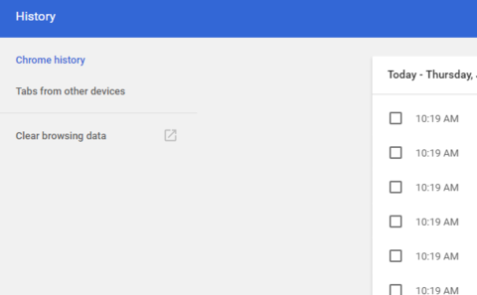
- Select Clear Browsing Data from the left-hand side. Set the Time Range set to All Time. Check-mark Cookies and other site data and Cached images and files and select Clear Data.
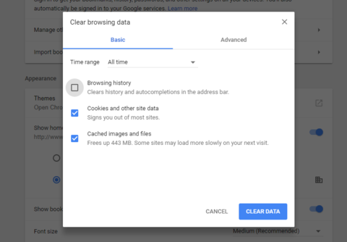

- If on a Windows computer, close and re-open Chrome to save your changes. If on an Apple computer, go to the Chrome menu on the top menu bar and select Quit for the changes to take effect.

Microsoft Edge for Windows 10
- Click the Tools menu (three dotted lines in the upper-right corner), and open the Settings menu.
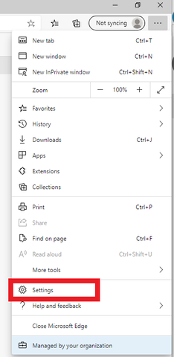

- Click Privacy, search, and services on the left-side menu.
- Under the section Clear browsing data, Click Choose what to clear.
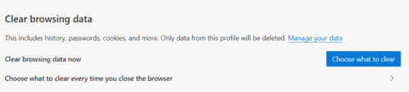

- Select Cookies and other site data and Cached images and files.
- Click Clear Now.
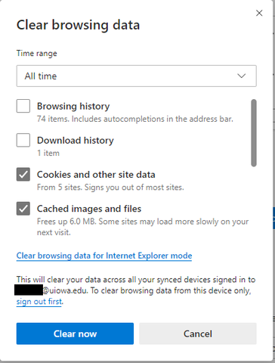

- Close Microsoft Edge completely for your changes to take effect.

Mozilla Firefox
- Click on the Tools bar.
- Click on Options (On Mac, it's labeled Preferences).
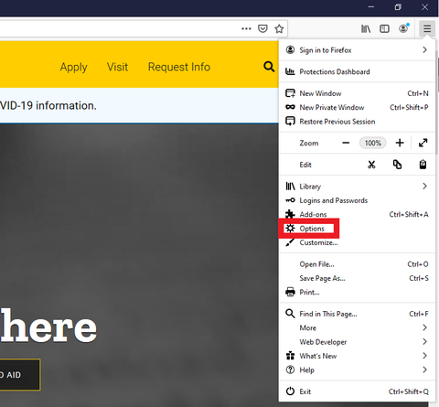
- On the menu to the left, select Privacy & Security.
- Under the Cookies and Site Data option, click the "Clear Data..." button.
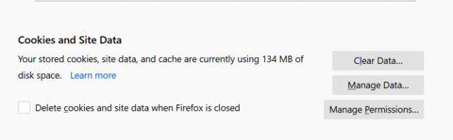

- Select only the two options and hit clear now.
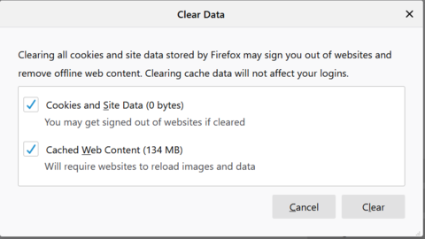

- If on a Windows computer, close and re-open Firefox to save your changes. If on an Apple computer, go to the Firefox menu on the top menu bar and select Quit for the changes to take effect.

